Software Requirements

Software Requirements

Specification

for

Software Requirements

Specification

for

Software Requirements

Specification

for

Software Requirements

Specification

For

**Software Requirements Specification**

**for**

**Makeup E-Commerce Application**

April 8, 2024

**Under the guidance of Prof. Kedar Deo Sir**

Anushka Bhagwat

Anushka Irkar

Table of Contents

**1. INTRODUCTION 1**

1.1 Purpose 1

1.2 Scope 1

1.3 Overview 1

**2. GENERAL DESCRIPTION 2**

2.1 Product Perspective 2

2.2 Product Functions 2

2.3 User Characteristics 2

**3. SPECIFIC REQUIREMENTS 2**

3.1 External Interface Requirements 3

*3.1.1 User Interfaces 3*

*3.1.2 Hardware Interfaces 3*

*3.1.3 Software Interfaces 3*

*3.1.4 Communications Interfaces 3*

3.2 Functional Requirements 3

*3.2.1 <Functional Requirement or Feature #1> 3*

*3.2.2 <Functional Requirement or Feature #2> 3*

3.5 Non-Functional Requirements 4

*3.5.1 Performance 4*

*3.5.2 Reliability 4*

*3.5.3 Availability 4*

*3.5.4 Security 4*

*3.5.5 Maintainability 4*

3.6 Inverse Requirements 4

3.7 Design Constraints 4

3.8 Logical Database Requirements 4

3.9 Other Requirements 4

**4. ANALYSIS MODELS 4**

4.1 Sequence Diagrams 5

5.**FUTURE SCOPE** 6

**Introduction**

The E-Commerce Application SRS document provides a detailed description of the requirements for the development of an eCommerce platform. This document outlines the functional and non-functional requirements, user interfaces, system features, and other specifications necessary for the successful implementation of the application.

**1. Purpose of the SRS**

* To provide a comprehensive description of the functionality and specifications for the makeup e-commerce website.
* To establish a clear understanding between the stakeholders and the development team regarding the system’s features and limitations.
* To serve as a reference document throughout the development, testing, and maintenance phases.

**2. Scope of the e-commerce platform**

* The e-commerce platform will be an online marketplace dedicated to makeup products.
* It will allow users to browse, select, and purchase a wide variety of makeup items from different brands.
* The platform will include features such as product recommendations, customer reviews, and makeup tutorials.

**3. References**

* Industry standards for e-commerce websites.
* Documentation from similar successful e-commerce platforms.
* Technical papers and articles related to e-commerce trends and technologies.

**4. Overview of the SRS document**

* This document is divided into several sections, each detailing different aspects of the system.
* The **Overall Description** provides a high-level view of the application and its interaction with other systems.
* **System Features** delve into the specific functionalities offered by the platform.
* **External Interface Requirements** describe the system’s interfaces with users, hardware, software, and communications.
* **Non-Functional Requirements** outline the system’s operational capabilities and constraints.
* **Other Requirements** cover any additional specifications not previously mentioned.

**Overall Description**

***Product Perspective***

The eCommerce application is a standalone system designed to facilitate online buying and selling of products. It interacts with users through web and mobile interfaces and integrates with external systems such as payment gateways and shipping carriers.

***Product Functions***

The application allows buyers to browse, search, and purchase products, while sellers can manage their inventory, view orders, and process transactions.

***User Classes and Characteristics***

**Buyers:** Individuals or organizations interested in purchasing products online.

**Sellers:** Individuals or businesses who offer products for sale on the platform.

***Operating Environment***

The application is web-based and accessible through modern web browsers on desktop and mobile devices. It requires an internet connection for full functionality.

***Design and Implementation Constraints***

The application must adhere to industry standards for security and privacy.

It should be compatible with popular web browsers and mobile devices.

It should support multiple languages and currencies for international users.

***User Documentation***

User documentation will include user manuals, FAQs, and online help resources to assist buyers and sellers in using the application effectively.

***Assumptions and Dependencies***

The application assumes users have basic knowledge of internet browsing and online shopping.

It depends on external services such as payment gateways and shipping carriers for payment processing and order fulfillment.

**Product Catalog**

* **Product Listings**: Detailed pages for each product, including images, descriptions, prices, and customer reviews.
* **Search and Filter**: Users can search for products and use filters like brand, price range, and color to find what they need.
* **Recommendations**: The system will suggest products based on user behavior and preferences.

**Order Management**

* **Order Placement**: Users can review their cart, add shipping information, and place an order.
* **Order Tracking**: Users can track the delivery status of their orders.
* **Returns and Refunds**: The system will handle return requests and process refunds according to the return policy.

**Payment Processing**

* **Secure Transactions**: The platform will support secure payment methods including credit cards, PayPal, and other online wallets.
* **Invoice Generation**: After payment, the system will generate an invoice for the user’s records.
* **Payment History**: Users can view their payment history for all transactions.

**Customer Support and Feedback**

* **Support Tickets**: Users can submit queries or issues through a ticketing system.
* **Live Chat**: Real-time assistance will be available through a live chat feature.
* **Feedback System**: Users can rate and review products, which will help in improving the service.

**Functional Requirements:**

**1. Product Catalog:**

- Display a wide range of makeup products with detailed descriptions, prices, and images.

- Allow users to filter and search for products based on various criteria like brand, category, price range, etc.

- Implement a smooth checkout process with multiple payment options.

**2. Personalization Features:**

- Utilize AI algorithms to recommend products based on user preferences, purchase history, and browsing behavior.

- Offer personalized discounts, promotions, and product suggestions to enhance user experience.

* **Add to Cart**: Users can add multiple items to their cart.
* **Edit Cart**: Users can change the quantity or remove items before checkout.
* **Save for Later**: Users can save items to purchase at a later date.

**3. Add, Update, Search, and Delete Functionality:**

- Enable users to add products to their cart, update quantities, search for specific items, and remove products from the cart.

- Implement a user-friendly interface for managing shopping preferences**.**

**Use Cases for Buyer:**

1. **Browse Products:**

Description: The buyer can browse through the available products in the eCommerce application.

Actors: Buyer

Basic Flow:

Buyer navigates to the product catalog.

Buyer views product listings.

Buyer filters products based on category, price, etc.

Buyer selects a product to view details.

1. **Search Products:**

Description: The buyer can search for specific products based on keywords.

Actors: Buyer

Basic Flow:

Buyer enters search keywords in the search bar.

System displays relevant search results.

Buyer selects a product from the search results.

1. **View Product Details:**

Description: The buyer can view detailed information about a specific product.

Actors: Buyer

Basic Flow:

Buyer selects a product from the product catalog or search results.

System displays product details such as description, price, availability, etc.

Buyer can view product images, ratings, and reviews.

1. **Add to Cart:**

Description: The buyer can add products to their shopping cart for purchase.

Actors: Buyer

Basic Flow:

Buyer selects the quantity of the product they want to purchase.

Buyer adds the product to their shopping cart.

System updates the shopping cart with the selected product and quantity.

1. **Checkout:**

Description: The buyer can proceed to checkout to complete the purchase.

Actors: Buyer

Basic Flow:

Buyer reviews the items in their shopping cart.

Buyer enters shipping and billing information.

Buyer selects a payment method.

Buyer confirms the order and completes the payment.

System processes the order and sends a confirmation to the buyer.

**Use Cases for Seller:**

1. **Manage Products:**

Description: The seller can add, edit, and delete products from their inventory.

Actors: Seller

Basic Flow:

Seller navigates to the product management interface.

Seller adds a new product with details such as name, description, price, etc.

Seller edits existing product information.

Seller deletes products that are no longer available.

1. **View Orders:**

Description: The seller can view and manage orders placed by buyers.

Actors: Seller

Basic Flow:

Seller navigates to the order management interface.

Seller views a list of orders with details such as order ID, buyer information, items ordered, etc.

Seller updates the status of orders (e.g., processing, shipped, delivered).

1. **Manage Inventory:**

Description: The seller can manage the inventory of their products.

Actors: Seller

Basic Flow:

Seller navigates to the inventory management interface.

Seller views a list of available products and their quantities.

Seller updates the quantity of products in stock.

Seller receives notifications for low stock levels and restocks products

**External Interface Requirements**

***User Interfaces***

The application will feature intuitive and user-friendly interfaces for buyers and sellers, including product listings, search functionality, shopping carts, and order management.

***Hardware Interfaces***

The application will run on standard web servers and client devices with internet connectivity. It will support various screen sizes and resolutions for desktop and mobile use.

***Software Interfaces***

The application will integrate with external systems such as payment gateways, shipping carriers, and inventory management software through APIs.

***Communication Interfaces***

Communication between the client and server will be handled over HTTP/HTTPS protocols. Real-time communication may be facilitated through WebSocket technology for features such as chat support.

**Web Interface**: The application will provide a web interface developed using **HTML**, **CSS**, and **JavaScript**.

**Responsive Design**: The design will be responsive, ensuring compatibility with various devices and screen sizes.

**Front-end Framework**: **React** will be used to create a dynamic and interactive user experience.

**Hardware Interfaces**

* **Compatibility**: The website will be accessible on standard computing devices including desktops, laptops, tablets, and smartphones.
* **Input Devices**: Users can interact with the website using standard input devices such as a mouse, keyboard, or touch screen.

**Software Interfaces**

* **Server-side**: The application backend will be developed using **Node.js**.
* **Database**: Integration with a database system for storing user data, product information, and transaction records.

**Communication Interfaces**

**HTTP/HTTPS**: The application will use HTTP/HTTPS protocols for secure communication between the client and server.

**APIs**: RESTful APIs will be used for handling requests and responses between the front-end and back-end systems.

**Data Formats**: Data interchange will primarily be in JSON format for ease of handling in JavaScript.

**System Features**

***Feature 1: Browse Products***

Description: Buyers can browse through available products by category or keyword.

Preconditions: User is logged in or accessing the application as a guest.

Postconditions: User can view product listings and select individual products for more details.

***Feature 2: Search Products***

Description: Buyers can search for specific products using keywords.

Preconditions: User is logged in or accessing the application as a guest.

Postconditions: User receives search results matching the entered keywords.

**Non-functional Requirements**

***Performance Requirements***

**1.Load Time**: Web pages should load within 3 seconds to ensure a smooth user experience.

**2. Scalability:**

- Design the app architecture to handle a large number of concurrent users and a growing product inventory.

It should support a minimum of 1000 concurrent users without significant performance degradation.

- Implement cloud-based solutions for scalability and performance optimization.

**3. Security:**

- Ensure data encryption, secure payment gateways, and protection against common cyber threats.

- Regular security audits and updates to maintain the integrity of user data.

**4. User-Friendly Interface:**

- Create a visually appealing and intuitive user interface that enhances the shopping experience.

- Optimize the app for mobile responsiveness and cross-browser compatibility.

**5.Availability:** The website should aim for 99.9% uptime, barring scheduled maintenance.

**Software Quality Attributes**

1. **Usability**: The interface should be intuitive and user-friendly, with a clear navigation structure.
2. **Reliability**: The system should have a robust error handling and recovery process to minimize downtime.
3. **Maintainability**: The code should be well-documented and structured to allow for easy updates and maintenance.

**Development Cost Estimate:**

The development cost for this project can vary based on the complexity of features, integrations, and customization required.

**ANALYSIS MODEL**

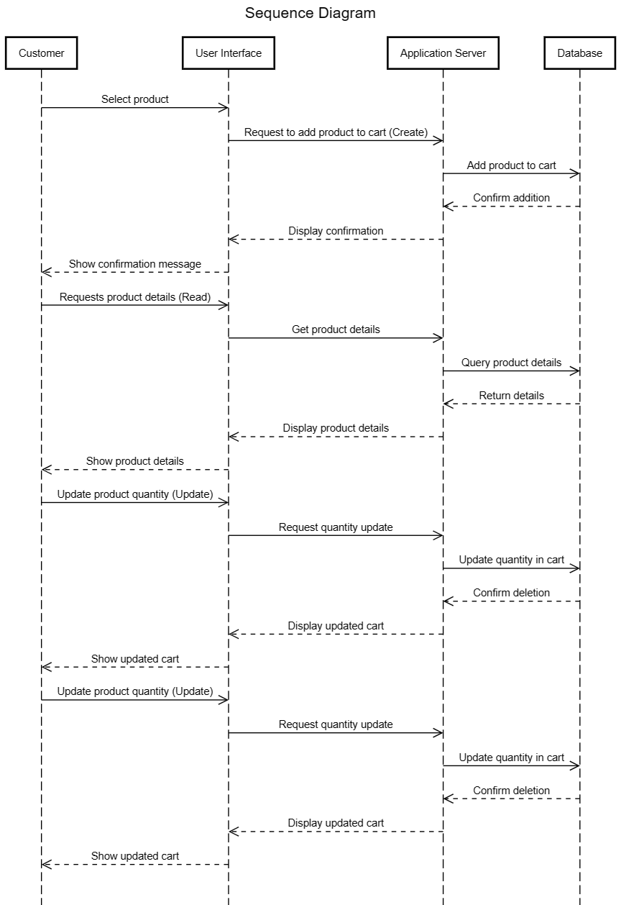

**Future scope**

**1. User Authentication:**

- Users should be able to create accounts, log in securely, and manage their profiles.

- Implement password encryption for secure user data storage.

**2. Order Tracking and History:**

- Provide users with real-time order tracking information and order history for reference.

- Send automated notifications for order status updates and shipping details**.**

**3. Feedback and Review System:**

**-** Allow users to rate and review products, providing valuable feedback for other customers.

- Implement a rating system to showcase popular products and improve user trust.